AZ204 LAbworks

Lab 02 - Implement task processing logic by using Azure Functions

Kaushik Ganguli

https://github.com/kaushikganguli

Table of Contents

Architecture diagram 1

Exercise 1: Create Azure resources 2

Exercise 2: Configure a local Azure Functions project 10

Exercise 3: Create a function that’s triggered by an HTTP request 13

Exercise 4: Create a function that triggers on a schedule 23

Exercise 5: Create a function that integrates with other services 28

Exercise 6: Deploy a local function project to an Azure Functions app 39

Exercise 7: Clean up your subscription 44

This specific document is meant for Lab 02: Implement task processing logic by using Azure Functions:

<https://microsoftlearning.github.io/AZ-204-DevelopingSolutionsforMicrosoftAzure/Instructions/Labs/AZ-204_lab_02.html>

GitHub repo:

<https://github.com/MicrosoftLearning/AZ-204-DevelopingSolutionsforMicrosoftAzure>

### Architecture diagram

[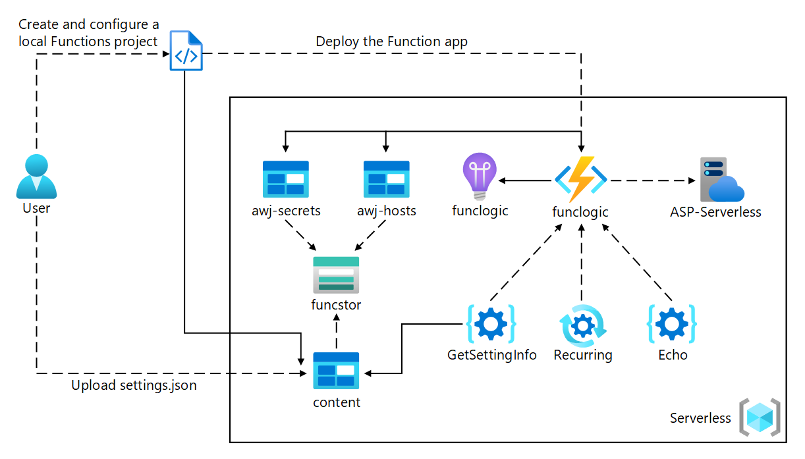](https://microsoftlearning.github.io/AZ-204-DevelopingSolutionsforMicrosoftAzure/Instructions/Labs/media/Lab02-Diagram.png)

### Exercise 1: Create Azure resources

#### Task 1: Open the Azure portal

1. On the taskbar, select the **Microsoft Edge** icon.
2. In the browser window, browse to the Azure portal ([https://portal.azure.com](https://portal.azure.com/)), and then sign in with the account you’ll be using for this lab.

#### Task 2: Create an Azure Storage account

1. In the Azure portal, use the **Search resources, services, and docs** text box to search for **Storage Accounts**, and then, in the list of results, select **Storage Accounts**.

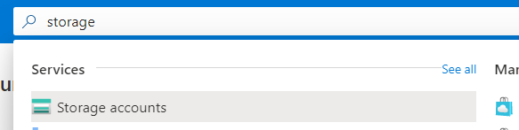

1. On the **Storage accounts** blade, select **+ Create**.

1. On the **Create a storage account** blade, on the **Basics** tab, perform the following actions, and then select **Review + create**:

| **Setting** | **Action** |
| --- | --- |
| **Subscription** drop-down list | Retain the default value. |
| **Resource group** section | Select **Create new**, enter **Serverless**, and then select **OK**. |
| **Storage account name** text box | Enter **funcstor**[yourname]. |
| **Region** drop-down list | Select **(US) East US**. |
| **Performance** section | Select the **Standard** option. |
| **Redundancy** drop-down list | Select **Locally-redundant storage (LRS)**. |

1. The following screenshot displays the configured settings in the **Create a storage account** blade.

1. On the **Review + create** tab, review the options that you selected during the previous steps.
2. Select **Create** to create the storage account by using your specified configuration.

1. On the **Overview** blade, select the **Go to resource** button to navigate to the blade of the newly created storage account.
2. On the **Storage account** blade, in the **Security + networking** section, select **Access keys**.

1. On the **Access keys** blade, select **Show keys**.

1. Review any one of the keys, and then copy the value of either of the **Connection string** boxes to the clipboard.
2. Open Notepad, and then paste the copied connection string value to Notepad. You’ll use this value later in this lab.

#### Task 3: Create a function app

1. On the Azure portal’s navigation pane, select the **Create a resource** link.
2. On the **Create a resource** blade, in the **Search services and marketplace** text box, enter **Function**, and then select Enter.
3. On the **Marketplace** search results blade, select the **Function App** result.

1. On the **Function App** blade, select **Create**.
2. On the **Create Function App** blade, on the **Basics** tab, perform the following actions, and then select **Next: Hosting**:

| Setting | Action |
| --- | --- |
| **Subscription** drop-down list | Retain the default value. |
| **Resource group** section | Select **Serverless**. |
| **Function App name** text box | Enter **funclogic**[yourname]. |
| **Publish** section | Select **Code**. |
| **Runtime stack** drop-down list | Select **.NET**. |
| **Version** drop-down list | Select **3.1**. |
| **Region** drop-down list | Select the **East US** region. |

1. The following screenshot displays the configured settings in the **Create Function App** blade.
2. On the **Hosting** tab, perform the following actions, and then select **Review + create**:

| Setting | Action |
| --- | --- |
| **Storage account** drop-down list | Select the **funcstor**[yourname] storage account. |
| **Operating System** section | Select **Linux**. |
| **Plan type** drop-down list | Select **Consumption (Serverless)**. |

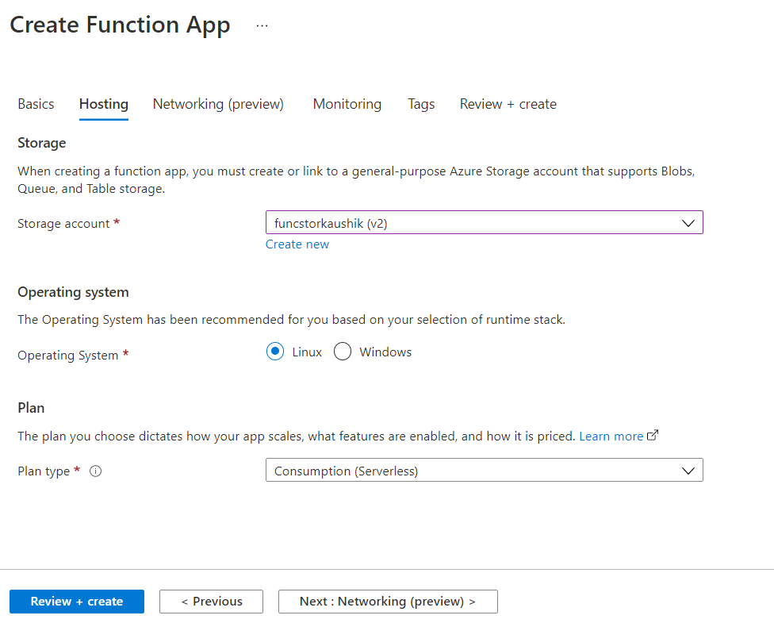

1. The following screenshot displays the configured settings on the **Hosting** tab on the **Create Function App** blade.
2. On the **Review + create** tab, review the options that you selected during the previous steps.
3. Select **Create** to create the function app by using your specified configuration.

#### Review

In this exercise, you created all the resources that you’ll use in this lab.

### Exercise 2: Configure a local Azure Functions project

#### Task 1: Initialize a function project

1. On the taskbar, select the **Windows Terminal** icon.
2. Run the following command to change the current directory to the **Allfiles (F):\Allfiles\Labs\02\Starter\func** empty directory

Download Azure Functions Core Tools from this location:

<https://docs.microsoft.com/en-us/azure/azure-functions/functions-run-local>

1. Run the following command to use the **Azure Functions Core Tools** to create a new local Azure Functions project in the current directory using the **dotnet** runtime:

func init --worker-runtime dotnet --force

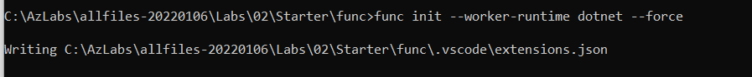

1. Close the **Windows Terminal** application.

#### Task 2: Configure a connection string

1. On the **Start** screen, select the **Visual Studio Code** tile.
2. On the **File** menu, select **Open Folder**.
3. In the **File Explorer** window that opens, browse to **Allfiles (F):\Allfiles\Labs\02\Starter\func**, and then select **Select Folder**.

Click on Show All files if you are using Visual Studio 2019

1. On the **Explorer** pane of the **Visual Studio Code** window, open the **local.settings.json** file.
2. Observe the current value of the **AzureWebJobsStorage** setting:

CodeCopy

"AzureWebJobsStorage": "UseDevelopmentStorage=true",

1. Update the value of the **AzureWebJobsStorage** by setting it to the **connection string** of the storage account that you recorded earlier in this lab.

1. Save the **local.settings.json** file.

#### Task 3: Build and validate a project

1. On the taskbar, select the **Windows Terminal** icon.
2. Run the following command to change the current directory to the **Allfiles (F):\Allfiles\Labs\02\Starter\func** empty directory:
3. Run the following command to **build** the .NET Core 3.1 project:

Download .net SDK6 from this location if you get the below error:

<https://dotnet.microsoft.com/en-us/download/dotnet/thank-you/sdk-6.0.101-windows-x64-installer>

Build succeeded with SDK 6

dotnet build

#### Review

In this exercise, you created a local project that you’ll use for Azure Functions development.

### Exercise 3: Create a function that’s triggered by an HTTP request

#### Task 1: Create an HTTP-triggered function

1. On the taskbar, select the **Windows Terminal** icon.
2. Run the following command to change the current directory to the **Allfiles (F):\Allfiles\Labs\02\Starter\func** empty directory:

CodeCopy

cd F:\Allfiles\Labs\02\Starter\func

1. Run the following command to use the **Azure Functions Core Tools** to create a new function named **Echo** using the **HTTP trigger** template:

CodeCopy

func new --template "HTTP trigger" --name "Echo"

1. Close the currently running **Windows Terminal** application.

#### Task 2: Write HTTP-triggered function code

1. On the **Start** screen, select the **Visual Studio Code** tile.
2. On the **File** menu, select **Open Folder**.
3. In the **File Explorer** window that opens, browse to **Allfiles (F):\Allfiles\Labs\02\Starter\func**, and then select **Select Folder**.
4. On the **Explorer** pane of the **Visual Studio Code** window, open the **Echo.cs** file.
5. In the code editor, observe the example implementation:

C#Copy

using System;

using System.IO;

using System.Threading.Tasks;

using Microsoft.AspNetCore.Mvc;

using Microsoft.Azure.WebJobs;

using Microsoft.Azure.WebJobs.Extensions.Http;

using Microsoft.AspNetCore.Http;

using Microsoft.Extensions.Logging;

using Newtonsoft.Json;

namespace func

{

public static class Echo

{

[FunctionName("Echo")]

public static async Task<IActionResult> Run(

[HttpTrigger(AuthorizationLevel.Function, "get", "post", Route = null)] HttpRequest req,

ILogger log)

{

log.LogInformation("C# HTTP trigger function processed a request.");

string name = req.Query["name"];

string requestBody = await new StreamReader(req.Body).ReadToEndAsync();

dynamic data = JsonConvert.DeserializeObject(requestBody);

name = name ?? data?.name;

string responseMessage = string.IsNullOrEmpty(name)

? "This HTTP triggered function executed successfully. Pass a name in the query string or in the request body for a personalized response."

: $"Hello, {name}. This HTTP triggered function executed successfully.";

return new OkObjectResult(responseMessage);

}

}

}

1. Delete all the content within the **Echo.cs** file.
2. Add the following lines of code to add **using directives** for the **Microsoft.AspNetCore.Mvc**, **Microsoft.Azure.WebJobs**, **Microsoft.AspNetCore.Http**, and **Microsoft.Extensions.Logging** namespaces:

C#Copy

using Microsoft.AspNetCore.Mvc;

using Microsoft.Azure.WebJobs;

using Microsoft.AspNetCore.Http;

using Microsoft.Extensions.Logging;

1. Create a new **public static** class named **Echo**:

C#Copy

public static class Echo

{ }

1. Observe the **Echo.cs** file again, which should now include:

C#Copy

using Microsoft.AspNetCore.Mvc;

using Microsoft.Azure.WebJobs;

using Microsoft.AspNetCore.Http;

using Microsoft.Extensions.Logging;

public static class Echo

{ }

1. Within the **Echo** class, add the following code block to create a new **public static** method named **Run** that returns a variable of type **IActionResult** and that also takes in variables of type **HttpRequest** and **ILogger** as parameters named request and logger:

C#Copy

public static IActionResult Run(

HttpRequest request,

ILogger logger)

{ }

1. Add the following code to append an attribute to the **Run** method of type **FunctionNameAttribute** that has its **name** parameter set to a value of **Echo**:

C#Copy

[FunctionName("Echo")]

public static IActionResult Run(

HttpRequest request,

ILogger logger)

{ }

1. Add the following code to append an attribute to the **request** parameter of type **HttpTriggerAttribute** that has its **methods** parameter array set to a single value of **POST**:

C#Copy

[FunctionName("Echo")]

public static IActionResult Run(

[HttpTrigger("POST")] HttpRequest request,

ILogger logger)

{ }

1. Observe the **Echo.cs** file again, which should now include the following code:

C#Copy

using Microsoft.AspNetCore.Mvc;

using Microsoft.Azure.WebJobs;

using Microsoft.AspNetCore.Http;

using Microsoft.Extensions.Logging;

public static class Echo

{

[FunctionName("Echo")]

public static IActionResult Run(

[HttpTrigger("POST")] HttpRequest request,

ILogger logger)

{ }

}

1. In the **Run** method, enter the following line of code to log a fixed message:

C#Copy

logger.LogInformation("Received a request");

1. Enter the following line of code to echo the body of the HTTP request as the HTTP response:

C#Copy

return new OkObjectResult(request.Body);

1. Observe the **Echo.cs** file again, which should now include the following code:

C#Copy

using Microsoft.AspNetCore.Mvc;

using Microsoft.Azure.WebJobs;

using Microsoft.AspNetCore.Http;

using Microsoft.Extensions.Logging;

public static class Echo

{

[FunctionName("Echo")]

public static IActionResult Run(

[HttpTrigger("POST")] HttpRequest request,

ILogger logger)

{

logger.LogInformation("Received a request");

return new OkObjectResult(request.Body);

}

}

1. Select **Save** to save your changes to the **Echo.cs** file.

#### Task 3: Test the HTTP-triggered function by using httprepl

1. On the taskbar, select the **Windows Terminal** icon.
2. Run the following command to change the current directory to the **Allfiles (F):\Allfiles\Labs\02\Starter\func** empty directory:

CodeCopy

cd F:\Allfiles\Labs\02\Starter\func

1. Run the following command to run the function app project:

CodeCopy

func start --build

1. On the taskbar, select the **Windows Terminal** icon again to open a new instance of the application.
2. When you receive the open command prompt, run the following command to start the **httprepl** tool, setting the base Uniform Resource Identifier (URI) to http://localhost:7071:

CodeCopy

httprepl http://localhost:7071

If httprepl is not available install it from using the command:

dotnet tool install -g Microsoft.dotnet-httprepl

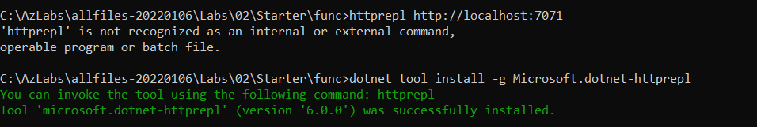

1. When you receive the tool prompt, run the following command to browse to the relative **api** directory:

CodeCopy

cd api

1. Run the following command to browse to the relative **echo** directory:

CodeCopy

cd echo

1. Run the following command to run the **post** command, sending in an HTTP request body set to a numeric value of **3** by using the **--content** option:

CodeCopy

post --content 3

1. Run the following command to run the **post** command, sending in an HTTP request body set to a numeric value of **5** by using the **--content** option:

CodeCopy

post --content 5

1. Run the following command to run the **post** command, sending in an HTTP request body set to a string value of **Hello** by using the **--content** option:

CodeCopy

post --content "Hello"

1. Run the following command to run the **post** command, sending in an HTTP request body set to a JavaScript Object Notation (JSON) value of **{“msg”: “Successful”}** by using the **--content** option:

CodeCopy

post --content "{"msg": "Successful"}"

1. Run the following command to exit the **httprepl** application:

CodeCopy

exit

1. Close all currently running instances of the **Windows Terminal** application.

#### Review

In this exercise, you created a basic function that echoes the content sent through an HTTP POST request.

### Exercise 4: Create a function that triggers on a schedule

#### Task 1: Create a schedule-triggered function

1. On the taskbar, select the **Windows Terminal** icon.
2. Run the following command to change the current directory to the **Allfiles (F):\Allfiles\Labs\02\Starter\func** empty directory:

CodeCopy

cd F:\Allfiles\Labs\02\Starter\func

1. When you receive the open command prompt, run the following command to use the **Azure Functions Core Tools** to create a new function named **Recurring**, using the **Timer trigger** template:

CodeCopy

func new --template "Timer trigger" --name "Recurring"

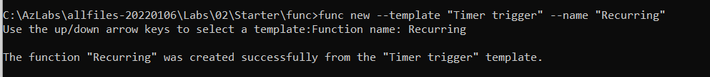

1. Close the currently running **Windows Terminal** application.

#### Task 2: Observe function code

1. On the **Start** screen, select the **Visual Studio Code** tile.
2. On the **File** menu, select **Open Folder**.
3. In the **File Explorer** window that opens, browse to **Allfiles (F):\Allfiles\Labs\02\Starter\func**, and then select **Select Folder**.
4. On the **Explorer** pane of the **Visual Studio Code** window, open the **Recurring.cs** file.
5. In the code editor, observe the implementation:

C#Copy

using System;

using Microsoft.Azure.WebJobs;

using Microsoft.Azure.WebJobs.Host;

using Microsoft.Extensions.Logging;

namespace func

{

public static class Recurring

{

[FunctionName("Recurring")]

public static void Run([TimerTrigger("0 */5 * * * *")]TimerInfo myTimer, ILogger log)

{

log.LogInformation($"C# Timer trigger function executed at: {DateTime.Now}");

}

}

}

#### Task 3: Observe function runs

1. On the taskbar, select the **Windows Terminal** icon.
2. Run the following command to change the current directory to the **Allfiles (F):\Allfiles\Labs\02\Starter\func** empty directory:

CodeCopy

cd F:\Allfiles\Labs\02\Starter\func

1. When you receive the open command prompt, run the following command to run the function app project:

CodeCopy

func start --build

1. Observe the function run that occurs about every five minutes. Each function run should render a simple message to the log.
2. Close the currently running **Windows Terminal** application.

#### Task 4: Update the function integration configuration

1. On the **Start** screen, select the **Visual Studio Code** tile.
2. On the **File** menu, select **Open Folder**.
3. In the **File Explorer** window that opens, browse to **Allfiles (F):\Allfiles\Labs\02\Starter\func**, and then select **Select Folder**.
4. On the **Explorer** pane of the **Visual Studio Code** window, open the **Recurring.cs** file.
5. In the code editor, observe the existing **Run** method signature:

C#Copy

[FunctionName("Recurring")]

public static void Run([TimerTrigger("0 */5 * * * *")]TimerInfo myTimer, ILogger log)

1. Update the **Run** method signature code block to change the schedule to run once every **30 seconds**:

C#Copy

[FunctionName("Recurring")]

public static void Run([TimerTrigger("*/30 * * * * *")]TimerInfo myTimer, ILogger log)

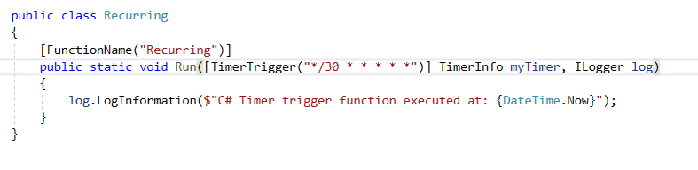

1. Select **Save** to save your changes to the **Recurring.cs** file.

#### Task 5: Observe function runs

1. On the taskbar, select the **Windows Terminal** icon.
2. Run the following command to change the current directory to the **Allfiles (F):\Allfiles\Labs\02\Starter\func** empty directory:

CodeCopy

cd F:\Allfiles\Labs\02\Starter\func

1. When you receive the open command prompt, run the following command to run the function app project:

CodeCopy

func start --build

1. Observe the function run that occurs about every 30 seconds. Each function run should render a simple message to the log.

1. Close the currently running **Windows Terminal** application.
2. Close the Visual Studio Code window.

#### Review

In this exercise, you created a function that runs automatically based on a fixed schedule.

### Exercise 5: Create a function that integrates with other services

#### Task 1: Upload sample content to Azure Blob Storage

1. On the Azure portal’s **navigation** pane, select the **Resource groups** link.
2. On the **Resource groups** blade, select the **Serverless** resource group that you created previously in this lab.
3. On the **Serverless** blade, select the **funcstor**[yourname] storage account that you created previously in this lab.
4. On the **Storage account** blade, select the **Containers** link in the **Data storage** section.
5. In the **Containers** section, select **+ Container**.

1. In the **New container** pop-up window, perform the following actions, and then select **Create**:

| Setting | Action |
| --- | --- |
| **Name** text box | Enter **content**. |
| **Public access level** drop-down list | Select **Private (no anonymous access)**. |

1. Return to the **Containers** section, and then select the recently created **content** container.
2. On the **Container** blade, select **Upload**.
3. In the **Upload blob** window, perform the following actions, and then select **Upload**:

| Setting | Action |
| --- | --- |
| **Files** section | Select the **Folder** icon. |
| **File Explorer** window | Browse to **Allfiles (F):\Allfiles\Labs\02\Starter**, select the **settings.json** file, and then select **Open**. |
| **Overwrite if files already exist** check box | Ensure that this check box is selected. |

#### Task 2: Create an HTTP-triggered function

1. On the taskbar, select the **Windows Terminal** icon.
2. Run the following command to change the current directory to the **Allfiles (F):\Allfiles\Labs\02\Starter\func** empty directory:

CodeCopy

cd F:\Allfiles\Labs\02\Starter\func

1. When you receive the open command prompt, run the following command to use the **Azure Functions Core Tools** to create a new function named **GetSettingInfo**, using the **HTTP trigger** template:

CodeCopy

func new --template "HTTP trigger" --name "GetSettingInfo"

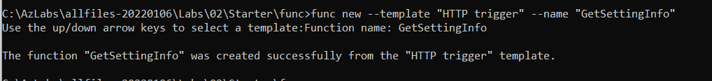

1. Close the currently running **Windows Terminal** application.

#### Task 3: Write HTTP-triggered and blob-inputted function code

1. On the **Start** screen, select the **Visual Studio Code** tile.
2. On the **File** menu, select **Open Folder**.
3. In the **File Explorer** window that opens, browse to **Allfiles (F):\Allfiles\Labs\02\Starter\func**, and then select **Select Folder**.
4. On the **Explorer** pane of the **Visual Studio Code** window, open the **GetSettingInfo.cs** file.
5. In the code editor, observe the example implementation:

C#Copy

using System;

using System.IO;

using System.Threading.Tasks;

using Microsoft.AspNetCore.Mvc;

using Microsoft.Azure.WebJobs;

using Microsoft.Azure.WebJobs.Extensions.Http;

using Microsoft.AspNetCore.Http;

using Microsoft.Extensions.Logging;

using Newtonsoft.Json;

namespace func

{

public static class GetSettingInfo

{

[FunctionName("GetSettingInfo")]

public static async Task<IActionResult> Run(

[HttpTrigger(AuthorizationLevel.Function, "get", "post", Route = null)] HttpRequest req,

ILogger log)

{

log.LogInformation("C# HTTP trigger function processed a request.");

string name = req.Query["name"];

string requestBody = await new StreamReader(req.Body).ReadToEndAsync();

dynamic data = JsonConvert.DeserializeObject(requestBody);

name = name ?? data?.name;

string responseMessage = string.IsNullOrEmpty(name)

? "This HTTP triggered function executed successfully. Pass a name in the query string or in the request body for a personalized response."

: $"Hello, {name}. This HTTP triggered function executed successfully.";

return new OkObjectResult(responseMessage);

}

}

}

1. Delete all the content within the **GetSettingInfo.cs** file.
2. Add the following lines of code to add **using directives** for the **Microsoft.AspNetCore.Http**, **Microsoft.AspNetCore.Mvc**, and **Microsoft.Azure.WebJobs** namespaces:

C#Copy

using Microsoft.AspNetCore.Http;

using Microsoft.AspNetCore.Mvc;

using Microsoft.Azure.WebJobs;

1. Create a new **public static** class named **GetSettingInfo**:

C#Copy

public static class GetSettingInfo

{ }

1. Observe the **GetSettingInfo.cs** file again, which should now include the following code:

C#Copy

using Microsoft.AspNetCore.Http;

using Microsoft.AspNetCore.Mvc;

using Microsoft.Azure.WebJobs;

public static class GetSettingInfo

{ }

1. Within the **GetSettingInfo** class, add the following code block to create a new **public static** expression-bodied method named **Run** that returns a variable of type **IActionResult** and that also takes in variables of type **HttpRequest** and **string** as parameters named request and json:

C#Copy

public static IActionResult Run(

HttpRequest request,

string json)

=> null;

**Note**: You are only temporarily setting the return value to **null**.

1. Add the following code to append an attribute to the **Run** method of type **FunctionNameAttribute** that has its **name** parameter set to a value of **GetSettingInfo**:

C#Copy

[FunctionName("GetSettingInfo")]

public static IActionResult Run(

HttpRequest request,

string json)

=> null;

1. Add the following code to append an attribute to the **request** parameter of type **HttpTriggerAttribute** that has its **methods** parameter array set to a single value of **GET**:

C#Copy

[FunctionName("GetSettingInfo")]

public static IActionResult Run(

[HttpTrigger("GET")] HttpRequest request,

string json)

=> null;

1. Add the following code to append an attribute to the **json** parameter of type **BlobAttribute** that has its **blobPath** parameter set to a value of **content/settings.json**:

C#Copy

[FunctionName("GetSettingInfo")]

public static IActionResult Run(

[HttpTrigger("GET")] HttpRequest request,

[Blob("content/settings.json")] string json)

=> null;

1. Add the following code to update the **Run** expression-bodied method to return a new instance of the **OkObjectResult** class passing in the value of the **json** method parameter as the sole constructor parameter:

C#Copy

[FunctionName("GetSettingInfo")]

public static IActionResult Run(

[HttpTrigger("GET")] HttpRequest request,

[Blob("content/settings.json")] string json)

=> new OkObjectResult(json);

1. Observe the **GetSettingInfo.cs** file again, which should now include the following code:

C#Copy

using Microsoft.AspNetCore.Http;

using Microsoft.AspNetCore.Mvc;

using Microsoft.Azure.WebJobs;

public static class GetSettingInfo

{

[FunctionName("GetSettingInfo")]

public static IActionResult Run(

[HttpTrigger("GET")] HttpRequest request,

[Blob("content/settings.json")] string json)

=> new OkObjectResult(json);

}

1. Select **Save** to save your changes to the **GetSettingInfo.cs** file.

#### Task 4: Register Azure Storage Blob extensions

1. On the taskbar, select the **Windows Terminal** icon.
2. Run the following command to change the current directory to the **Allfiles (F):\Allfiles\Labs\02\Starter\func** empty directory:

cd F:\Allfiles\Labs\02\Starter\func

1. When you receive the open command prompt, run the following command to register the [Microsoft.Azure.WebJobs.Extensions.Storage](https://www.nuget.org/packages/Microsoft.Azure.WebJobs.Extensions.Storage/4.0.4) extension:

func extensions install --package Microsoft.Azure.WebJobs.Extensions.Storage --version 4.0.4

1. Run the following command to build the .NET project and to validate the extensions were installed correctly:

CodeCopy

dotnet build

1. Close all currently running instances of the **Windows Terminal** application.

#### Task 5: Test the function by using httprepl

1. On the taskbar, select the **Windows Terminal** icon.
2. Run the following command to change the current directory to the **Allfiles (F):\Allfiles\Labs\02\Starter\func** empty directory:

CodeCopy

cd F:\Allfiles\Labs\02\Starter\func

1. When you receive the open command prompt, run the following command to run the function app project:

CodeCopy

func start --build

1. On the taskbar, select the **Windows Terminal** icon again to open a new instance of the **Windows Terminal** application.
2. When you receive the open command prompt, run the following command to start the **httprepl** tool setting the base Uniform Resource Identifier (URI) to http://localhost:7071:

CodeCopy

httprepl http://localhost:7071

**Note**: An error message is displayed by the **httprepl** tool. This message occurs because the tool is searching for a Swagger definition file to use to traverse the API. Because your function project doesn’t produce a Swagger definition file, you’ll need to traverse the API manually.

1. When you receive the tool prompt, run the following command to browse to the relative **api** endpoint:

CodeCopy

cd api

1. Run the following command to browse to the relative **getsettinginfo** endpoint:

CodeCopy

cd getsettinginfo

1. Run the following command to run the **get** command for the current endpoint:

CodeCopy

get

1. Observe the JSON content of the response from the function app, which should now include:

CodeCopy

{

"version": "0.2.4",

"root": "/usr/libexec/mews_principal/",

"device": {

"id": "21e46d2b2b926cba031a23c6919"

},

"notifications": {

"email": "joseph.price@contoso.com",

"phone": "(425) 555-0162 x4151"

}

}

1. Run the following command to exit the **httprepl** application:

CodeCopy

exit

1. Close all currently running instances of the **Windows Terminal** application.

#### Review

In this exercise, you created a function that returns the content of a JSON file in Storage.

### Exercise 6: Deploy a local function project to an Azure Functions app

#### Task 1: Deploy using the Azure Functions Core Tools

1. On the taskbar, select the **Windows Terminal** icon.
2. Run the following command to change the current directory to the **Allfiles (F):\Allfiles\Labs\02\Starter\func** empty directory:

CodeCopy

cd F:\Allfiles\Labs\02\Starter\func

1. When you receive the open command prompt, run the following command to login to the Azure Command-Line Interface (CLI):

CodeCopy

az login

If you get the below error, install Azure CLI from this location:

<https://docs.microsoft.com/en-us/cli/azure/install-azure-cli-windows?tabs=azure-cli>

After installation:

1. In the **Microsoft Edge** browser window, enter the email address and password for your Microsoft account, and then select **Sign in**.
2. Return to the currently open **Windows Terminal** window. Wait for the sign-in process to finish.
3. Run the following command to publish the function app project:

CodeCopy

func azure functionapp publish <function-app-name>

**Note**: For example, if your **Function App name** is **funclogicstudent**, your command would be func azure functionapp publish funclogicstudent. You can review the documentation to [publish the local function app project][azure-functions-core-tools-publish-azure] using the **Azure Functions Core Tools**.

1. Wait for the deployment to finalize before you move forward with the lab.
2. Close the currently running **Windows Terminal** application.

#### Task 2: Validate deployment

1. On the taskbar, select the **Microsoft Edge** icon, and select the tab that contains the Azure portal ([https://portal.azure.com](https://portal.azure.com/)).
2. On the Azure portal’s **navigation** pane, select the **Resource groups** link.
3. On the **Resource groups** blade, select the **Serverless** resource group that you created previously in this lab.
4. On the **Serverless** blade, select the **funclogic**[yourname] function app that you created previously in this lab.
5. On the **App Service** blade, select the **Functions** option in the **Functions** section.

1. On the **Functions** pane, select the existing **GetSettingInfo** function.

1. In the **Function** blade, select the **Code + Test** option in the **Developer** section.

1. In the function editor, select **Test/Run**.

1. In the popup dialog that appears, perform the following actions:
   * In the **HTTP method** list, select **GET**.

1. Select **Run** to test the function.
2. Observe the results of the test run. The JSON content should now include the following code:

{

"version": "0.2.4",

"root": "/usr/libexec/mews_principal/",

"device": {

"id": "21e46d2b2b926cba031a23c6919"

},

"notifications": {

"email": "joseph.price@contoso.com",

"phone": "(425) 555-0162 x4151"

}

}

#### Review

In this exercise, you deployed a local function project to Azure Functions and validated that the functions work in Azure.

### Exercise 7: Clean up your subscription

#### Task 1: Open Azure Cloud Shell and list resource groups

1. In the Azure portal, select the **Cloud Shell** icon [Cloud Shell icon](https://microsoftlearning.github.io/AZ-204-DevelopingSolutionsforMicrosoftAzure/Instructions/Labs/media/az204_lab_CloudShell.png) to open a new Bash session. If Cloud Shell defaults to a PowerShell session, select **PowerShell**, and in the drop-down menu, select **Bash**.

**Note**: If this is the first time you’re starting **Cloud Shell**, when prompted to select either **Bash** or **PowerShell**, select **PowerShell**. When you’re presented with the **You have no storage mounted** message, select the subscription you’re using in this lab, and then select **Create storage**.

#### Task 2: Delete a resource group

1. On the **Cloud Shell** pane, run the following command to delete the **Serverless** resource group:

CodeCopy

az group delete --name Serverless --no-wait --yes

**Note**: The command executes asynchronously (as determined by the –no-wait parameter), so while you’ll be able to run another Azure CLI command immediately afterwards within the same Bash session, it’ll take a few minutes before the resource groups are removed.

1. Close the **Cloud Shell** pane in the portal.

#### Task 3: Close the active application

* Close the currently running Microsoft Edge application.

#### Review

In this exercise, you cleaned up your subscription by removing the resource group that was used in this lab.